**3 Page Website.**

**The front/home page of the website needs to be a store with the below heading.**

**I would like a cart checkout option right on the front page with all of the products and color options with pictures next to each item.**

**I’d like the most straight-forward checkout option you have.**

**Page 1: DaoScience.com Website Outline—“Store”**

|  |
| --- |
| **Store Brand Contact** |
| The above is the heading layout for the front page of the website “Store” with edits below. The above is simply a picture I cropped from my packaging design, which is also below.  Note: All print is Arial Bold and often in small caps.  Instead of “~Fits BIC & Other Lighters~”, please change the top line in yellow on black to:  **~What’s Your Ritual?~**  . |

Below is a packaging label made in Photoshop:

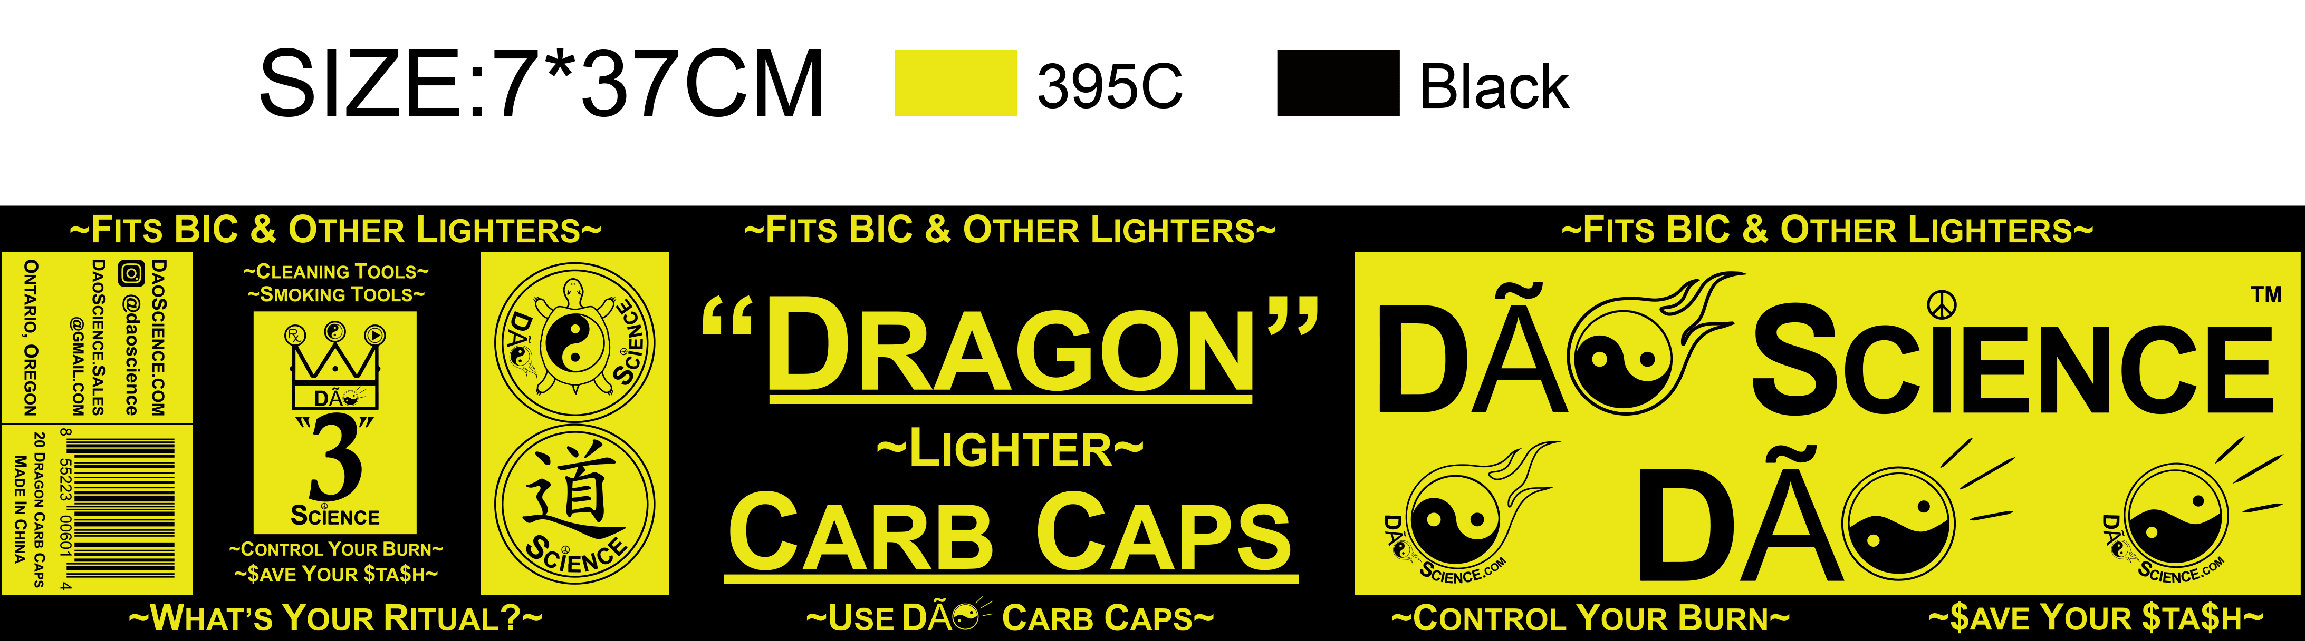

**Page 2: DaoScience.com Website Outline—“Brand”**

The website can be a simple layout with picture left, text right; text left, picture right, as below.

|  |  |  |
| --- | --- | --- |
|  | G:\DAYSTAR LOGOS\Don Bennett NEW\August 2015 - Revisions\DAO_Science_Inline_Logo.jpg  Designs and Manufactures:  **Quality Tools and Accessories** **for Smoking Markets.**  **Our future is Burning Bright.**  **We are the Original Inventors of**  **Innovative Silicone Rubber Carb Caps.**  ~**Control Your Burn**~  **Avoid unnecessary waste and save money.**  **Use** **Carb Caps to snuff out your Bowls**.  **Control the flow of oxygen/smoke through your pipe while preserving the Cannabis in the bowl.** | |
|  | | |
| **Brand**  **~What does it mean to you?~**  **The** G:\DAYSTAR LOGOS\Don Bennett NEW\August 2015 - Revisions\DAO_Science_Inline_Logo.jpg **Brand combines the concept of wholesome balanced positive philosophy with the truth and precision of Science.**  **The** G:\DAYSTAR LOGOS\Don Bennett NEW\August 2015 - Revisions\DAO_Science_Inline_Logo.jpg **Brand often relates its products to things found in Nature.**  **For example, a “Turtle” symbolizes longevity, wisdom, caution, and slow and steady wins the race.**  **A “Dragon” symbolizes power and excellence. In ancient mythology, Dragons offered help and guidance. A Dragon can take multiple forms representing different imaged moralities. For example, a Dragon can be an angel or a devil.** | |  |
|  |  | |
| **“Dao”**  **(noun) (In Chinese philosophy):**  **The absolute principle underlying the universe, combining within itself the principles of Yin and Yang, and signifying the way, or code of behavior, which is in harmony with the natural order and balance of all things.**  **The Chinese character “,” spelled “Dao” or “Tao” in English (same thing), means “the Path,” “the Way,” “the Method,” or “the Road.”**  **Depending on the context of its use, “Dao” can also mean “to Reason,” “a Skill,” “a Principle,” “a Truth,” or “Morality.”** |  | |
|  | | |
|  | | **“Science”**  **(noun):**  **The word “Science” symbolizes “Precision” as well as “Nature”; particularly the Laws of Physics on the one hand (Tangible), and the general dynamic of “Peace Science” on the other hand (Intangible Balance).**  **Thus: “Dao” + “Science”**  **The concept of Dao Science suggests “Natural Balance” and “Natural Truth.”** |
|  | | |
| **Yin~Yang**  **The Yin~Yang symbolizes many things in Dao Science:**  **The Circular Nature of Life.**  **The Shape of the Planets.**  **The Philosophy of Opposites.**  **The “Balance” in Nature that Occurs at the Center of the Two Opposite Sides of All Things.**  **The Yin~Yang symbol is intended to express a philosophy of two opposite sides with a line where “balance” occurs down the center.**  **Thus, the Yin~Yang symbolizes: left, center, and right; or top, middle, and bottom.** |  | |
|  | | |
|  | | **The Number “3”**  **The number “3” has multiple symbolic meanings and represents:**  **The three parts of the Yin~Yang (Top, Middle, Bottom ~ Left, Center, Right).**  **The Medical, Philosophical, and Recreational uses of Cannabis.**  **The “Toke Sign,” which is a universal sign of Peace, Sharing, and Brother/Sisterhood.  Heaven, Earth, and Underworld.** |
|  | | |
|  | | |

**Page 3: DaoScience.com Website Outline—“Contact”**

|  |  |
| --- | --- |
| **DaoScience.com**  **Dao Science, LLC**  **PO Box XXX**  **Ontario, OR 97914** | **[Instagram Logo]: @daoscience**  [**DaoScience.Sales@gmail.com**](mailto:DaoScience.Sales@gmail.com)  **541-239-3964** |



